The summer is a time to relax, try new things and spend time with people. But the summer may also be a time of difficulty for some.

If you are worried or concerned about your mental health or wellbeing or that of a friend Find Get Give has resources to help. From books, to apps, to videos, it provides you with details of local services. Check it out www.findgetgive.com

Find Get Give on Twitter Facebook Instagram

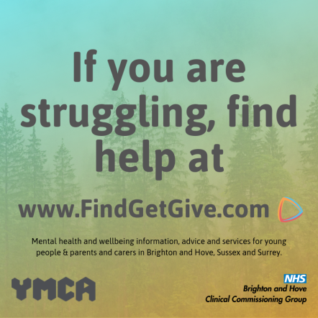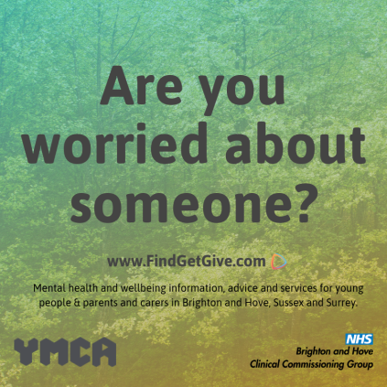

It will then sign post to information and support available at over the summer.

Guide for parents / carers to support positive mental health and wellbeing:

- This has been developed by young people, parents and carers to help support positive mental health and wellbeing: https://ymcarighthere.com/wp-content/uploads/2017/09/Parents_Guide-latest-version.pdf

Direct Emotional and Mental Health for Children and Young People support locally:
- Primary Mental Health Workers can provide advice and guidance on children and young people’s emotional mental health and wellbeing. (Professionals will need parental consent to discuss a named young person under 16, or can seek general advice.)
  - Telephone Consultation Line 01273 – 293331 from 10am – 3pm Mon, Tues, Thursday
  - Drop-in groups available call for details and to book 02173 294411 or email bhiss@brighton-hove.gov.uk

- For support and information for children and their families after the death of a parent or sibling visit www.winstonswish.org

- For confidential support and advice for young people struggling with thoughts of suicide https://papyrus-uk.org/

- For emotional support to anyone in emotional distress, struggling to cope, or at risk of suicide www.samaritans.org/branches/brighton-hove-and-district-samaritans/ Tel: 116 123

- For confidential support, advice and access to service if you are worried about a young person’s substance misuse visit https://www.socialsubcultural.com/ruok/ or call the consultation line on 01273 – 293966 Monday– Friday between 12 and 3pm

- You should also consider contacting your GP. They can provide advice, and where appropriate arrange support services for you.

Here are two phone numbers young people as well as parents and carers can call if you want information or advice on mental health and wellbeing:
  - Child and Adolescent Mental Health Services: Duty: 0300 304 0061 (9am-5pm)
  - Sussex Mental HealthLine: 0300 5000 101 (5pm-9am, weekends, bank holidays)

Texting services, apps

- The Mix provides support to under 25’s - from mental health to money, from homelessness to finding a job, from break-ups to drugs. Young people can get in touch and access support online, via social media or via the free, confidential helpline https://www.themix.org.uk/
- Childline: 0800 1111 / online chat
- Young Minds Crisis Messenger text YM to85258
- www.youngminds.org.uk Apps: Calm Harm, Smiling Mind, Stay Alive, Anti Stress

