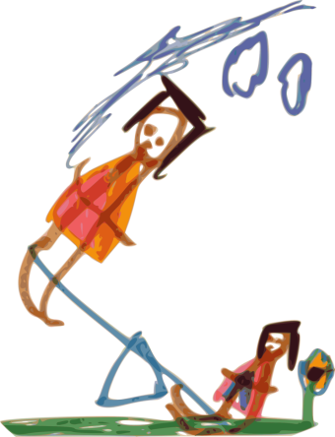
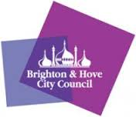
Emotional Mental Health and Wellbeing
Summer Support Workshops and Groups
August and September 2019
Hosted by the Schools Wellbeing Service
Our team of Primary Mental Health Workers are offering a telephone helpline and group sessions for any parents or carers who are concerned about their child’s emotional mental health and wellbeing. This is a chance to have an informal chat about any questions you may have in a safe, friendly environment.
Workshop around transition to school  for parent/carers and children at:  Hove Town Hall Room G91 | Tuesday 3 September, 4-6pm
Walk and talk session for parent/carers and children  at: Stanmer Park, Brighton BN1 9PY  MEET in front of the church by the pond  See Google info | Wednesday 7 August, 2-4pm
Walk and talk session for parents and children  at: Easthill Park  MEET in front of the café  Easthill Way, Portslade, Brighton BN41 2FA | Wednesday 21 August, 2-4pm
Self-harm parent/carer session for parents & carers only at:  Brighton & Hove Inclusion Support Service,  Brighton & Hove Music & Arts Building  County Oak Avenue, Brighton, BN1 8DJ | Wednesday 31 July, 9:30-11am  Wednesday 28 August, 9:30-11am

Spaces are limited. So please call 02173 294411 or email bhiss@brighton-hove.gov.uk to book places for the session you would like to attend and tell us the number of people attending.
“My child thinks everybody else seems so
happy and normal. I wish I knew how to support their mental health issues.”

Emotional Mental Health and Wellbeing
Summer Telephone Consultation Line
Provided by the Schools Wellbeing Service
01273 293331 from 10am to 3pm Mon, Tue, Thurs
This phone line will put parents, carers and professionals in touch with a primary mental health worker who will provide advice and guidance on children and young people’s emotional mental health and wellbeing. Professionals will need parental consent to discuss a named young person under 16, or can seek general advice.
For any crisis or urgent concerns please call:

Specialist CAMHS: 0300 304 0061 (office hours)

Sussex Mental Health Line: 0300 5000 101 (out of hours: 5pm-9am, weekends, bank holidays)

Useful Phone Numbers/Websites/Apps:
Childline: 0800 1111 / online chat
Samaritans: 116 123
www.findgetgive.com
www.youngminds.org.uk
Apps: Calm Harm, Smiling Mind, Stay Alive

